***Mawlana Bhashani Science and Technology University***



**Department of Information and Communication Technology**

|  |  |  |
| --- | --- | --- |
| **Course Code** | **:** | ***ICT-3210*** |
| **Course Name** | **:** | ***Software Engineering Lab*** |
| **Name of the Lab** | **:** | ***Activity Diagram of the project*** |
| **Lab No.** | **:** | ***01*** |

**Submitted by:**

**Md. Nazmul Hasan**

**ID: IT-17005**

**Session: 2016-17**

**3rd Year 2nd Semester**

**Submitted to:**

**Mr. Tanvir Rahman**

**Lecturer**

**Dept. of ICT, MBSTU**

**Santosh, Tangail-1902**

**Date of Submission**: 31-October-2020

***Online Credit fee payment system***

‘XYZ Science and Technology University’ is a leading university in Bangladesh. The university authorities have come to our software firm with a problem. The credit fee payment process in their university is very much backdated. So, they want to automate their credit fee payment process.

**Requirement:** The requirements of their software are given the following:

1. First of all, they want to register their students’ information through this software.
2. The student will register with the software by giving his/her name, ID, session, mobile, email, and also should give a password to secure his/her registered account.
3. The registered office of each department will be the admin of their students’ database. They will handle all admin panel tasks. The individual department register office will create the course database for each semester.
4. The individual admin will have their ID and password. So, the database of each department is being secured from unauthorized access.
5. The students of the university can also update their information from time to time.
6. The university authority can notify them when their semester final examination will occur. They can also send the notice to their students through email and mobile messages.
7. When a student logs in with this software, he/ she will give just his/her ID and password to fill up the registration form for the current semester. The software will automatically provide his/her information from a database that he/she previously gives to create a registration.
8. After that, the students will provide their semester final examination information that he/she will want to participate in. Then the software will automatically fetch his current semester final courses with credit.
9. The students also register for their previous semester backlog courses through this software. They just click to ‘add more’ button, below their current semester courses’ information.
10. After giving all this information above, the student can see his/her total semester credits that he has taken to the current semester.
11. Then he/she has to click on the submit button. It will bring him/her to the payment page. He/she can see the payment information for his/her current semester. It includes his/her semester tuition fee, current credit fee, backlog credit fee, lab fee, transport fee, medical fee, and so on of the individual department.
12. After checking out his/her payment information, the student will click on payment methods whatever he wants to choose.
13. Then the software will take him/her to the payment gateway page (i.e bKash, Rocket, etc.) whatever he/she selects.
14. After paying his/her bill through the payment gateway, the software will automatically send him/her a confirmation mail and message that his/her bill has successfully paid.
15. At last, the will logout from the software to click on the logout button. The software will automatically remove his/ her session.

**Activity diagram:** Activity diagram is another important diagram in UML to describe the dynamic aspects of the system.

Activity diagram is basically a flowchart to represent the flow from one activity to another activity. The activity can be described as an operation of the system.

The control flow is drawn from one operation to another. This flow can be sequential, branched, or concurrent. Activity diagrams deal with all type of flow control by using different elements such as fork, join, etc.

**Purpose of Activity Diagrams:** The basic purposes of activity diagrams is similar to other four diagrams. It captures the dynamic behaviour of the system. Other four diagrams are used to show the message flow from one object to another but activity diagram is used to show message flow from one activity to another.

Activity is a particular operation of the system. Activity diagrams are not only used for visualizing the dynamic nature of a system, but they are also used to construct the executable system by using forward and reverse engineering techniques. The only missing thing in the activity diagram is the message part.

It does not show any message flow from one activity to another. Activity diagram is sometimes considered as the flowchart. Although the diagrams look like a flowchart, they are not. It shows different flows such as parallel, branched, concurrent, and single.

The purpose of an activity diagram can be described as –

1. Draw the activity flow of a system.
2. Describe the sequence from one activity to another.
3. Describe the parallel, branched and concurrent flow of the system.

**The Activity diagram of “Online Credit Fee Payment System”**

**Admin activity diagram:**

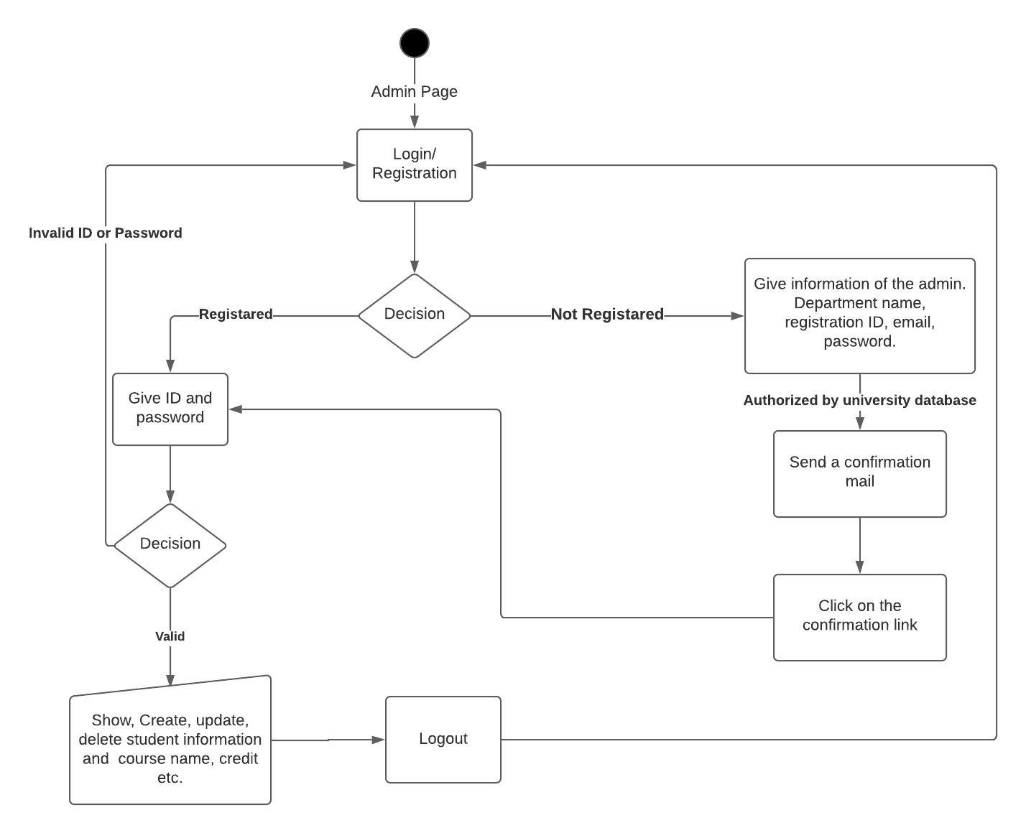

**Fig.** Activity diagram of Admin panel.

**Student’s activity diagram:**

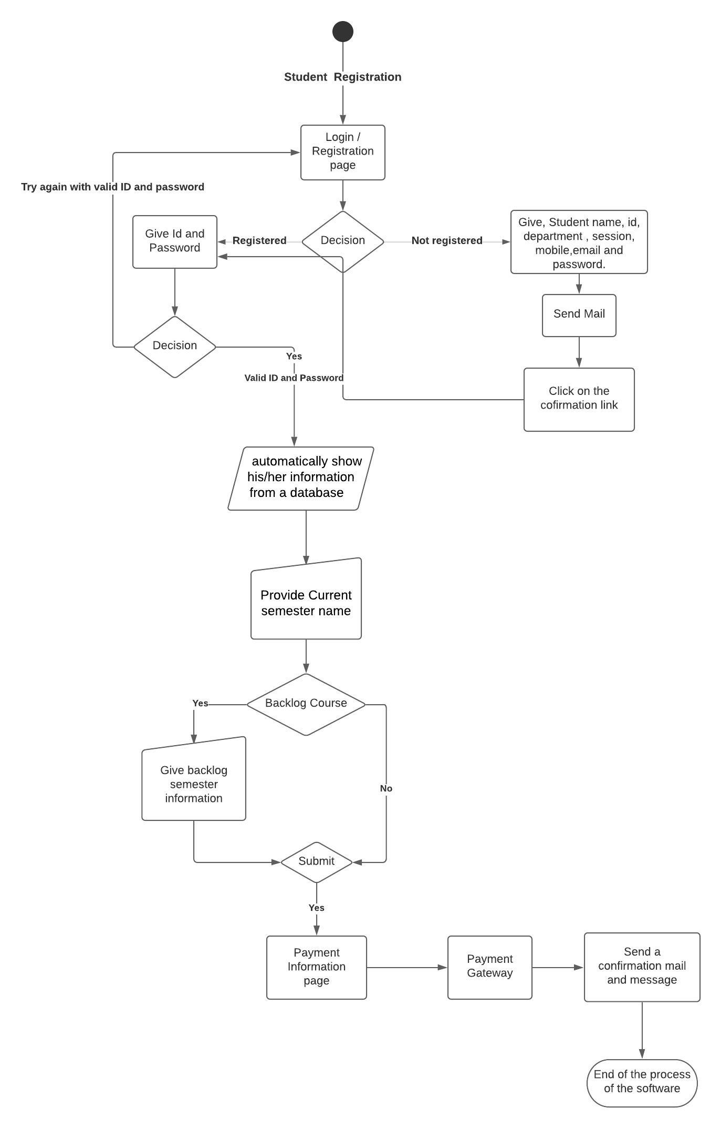

**Fig.** Activity diagram of User panel.

**Conclusion:** From this lab, I come to learn the activity diagram of my project. The activity diagram is one of the most important part of UML diagram. The activity can be described as an operation of the system. Our course teacher suggest us to use online diagram tool(Lucid Chart).